- You will use Java.
- You will use MySQL or PostgreSQL.

We consider the Product, Depot and Stock relations / tables that you implemented in previous assignments.

The key of product is #prod.
The key of depot is #dep.
The key of stock is #prod, #dep.

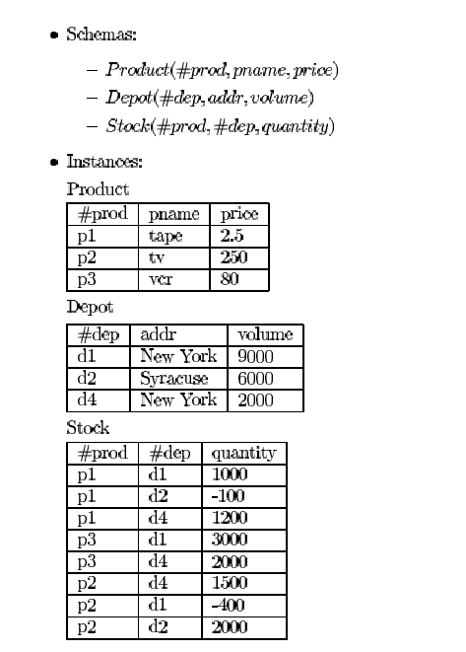

- Reverse engineering (20 points)

What ERD corresponds to the provided schema?

You will present your ERD during the presentation. You will also submit it in BlackBoard.

- Write the following transactions in Java with MySQL. A transaction implements the ACID properties. If the code you will provide does not implement the ACID properties, you will get 0 for the question. (50 points)

Group 1 – The product p1 is deleted from Product and Stock.

Group 2 – The depot d1 is deleted from Depot and Stock.

Group 3 – The product p1 changes its name to pp1 in Product and Stock.

Group 4 – The depot d1 changes its name to dd1 in Depot and Stock.

You will provide the code in GitHub. No need to submit it in BlackBoard.

You will demo the transaction during the presentation.

- Do the GitHub exercise (INDIVIDUAL). (15 points – Individual)

Post your GitHub url in the required Google Docs.

- Each member of the team posts the code of Week 5 (SQL) and Week 6 (Java) in GitHub. (INDIVIDUAL) (15 points – Individual)

